# R1 Documentation

**Name of the Developers:** Sayad Pervez B, Ulagaraja J

**Institute:** Rajalakshmi Engineering College

**Email id:**

##### sayadpervez.b.2019.ece@rajalakshmi.edu.in

##### [ulagaraja.j.2019.ece@rajalakshmi.edu.in](mailto:shivashankar.u.2018.ece@rajalakshmi.edu.in)

**Department**: ECE

**Discipline**: ECE

**Name of the Lab**: Communication Systems Laboratory (C.S.L)

**Name of experiment**: Characteristics of a Zener Diode

**Focus Area**: Experimental Analysis Method

**About the experiment:**

The goal of this experiment is to understand the Characteristics and Regulation Modes of Zener Diode. Zener Diode is a special kind of diode in which current flow in the forward direction is permitted normally and current flow in reverse direction is also possible when the voltage increases above the breakdown or Zener Voltage. Ideal Zener Diode voltage is 2.4 Volts.

**Learning Objectives and Cognitive Level:**

|  |  |  |  |
| --- | --- | --- | --- |
| **S No.** | **Learning Objectives** | **Cognitive level** | **Action Verb** |
| 1 | To familiarize the Basics of Zener Diode | Understand | Identify |
| 2 | To experimentally verify the load regulation of Zener Diode | Apply | Calculate |
| 3 | To experimentally verify the line regulation of Zener Diode. | Apply | Calculate |
| 4 | To identify the V-I characteristics of Zener Diode. | Evaluate | Conclude |

2. **Instructional Strategy**:

**2. 1 Instructional Strategy**: Experiential Learning

**2.2 Assessment Method**: Formative Assessment, Pre-test and Post-test (Multiple choice questions)

**2.3 Description of section:**

• Theory aspects for the Zener diode experiment will be provided for better understanding.

• Step by step procedure to perform the simulation will be given.

• Pre-test questions (based on the online manual of Zener Diode provided) & post test questions (based on the observations recorded) will be provided to evaluate the students understanding level.

• Additional reference materials will be provided.

3. **Task & Assessment Questions**

|  |  |  |  |  |
| --- | --- | --- | --- | --- |
| **No** | **Instructions given by the Teacher** | **Tasks to be done by the students** | **Assessment questions aligned to the task** | **Assessment questions Solutions** |
| 1) | Read the theory and procedure to perform the Zener Diode to perform simulations with ease. | Click on the theory and procedure icons to view the theory and step by step procedure to guide the student to perform the simulation of Zener Diode | Conceptual question (to be asked by teacher): 1. Explain the Basics of Zener Diode | Zener Diode is a special kind of diode in which current flow in forward direction is permitted normally and current flow in the reverse direction is permitted when the voltage is greater than the Zener Breakdown Voltage. |
| 2) | With battery voltage and amperage set to a constant value, vary the rheostat values. | Construct the circuit and vary the rheostat values | Conceptual question (to be asked by teacher):  2. What are the regulations of Zener Diode | Line regulation and load regulation. |
| 3) | With battery amperage, series resistance and load resistance set to a constant value, vary the battery voltage. | Construct the circuit and vary the battery voltage | Conceptual question (to be asked by teacher):  3.what is line regulation? | In Line Regulation the load and series resistance are fixed and the input is varied. |
| 4) | With battery voltage, amperage and series resistance set to a constant value, vary the load resistance values. | Construct the circuit and vary the load resistance | Conceptual question (to be asked by teacher):  4.what is load regulation? | In Load Regulation the input voltage and series resistance are fixed and the load resistance is varied. |
| 5) | Examine the graphical observations of VI characteristics of the Zener diode. | With rheostat value varying and rest of the input parameters constant, plot the VI characteristics of a Zener diode. | Conceptual question (to be asked by teacher):  5.Explain the applications of Zener Diode | 1. Voltage Regulator  2.Clippers & Clambers |

4. **Simulator Interactions:**

|  |  |  |  |
| --- | --- | --- | --- |
| **S. No** | **What students will do?** | **What Simulator will do?** | **Purpose of the task** |
| 1 | Click on the theory and procedure given in the home page to carry out the Zener Diode experiment. | Show the theory and procedure to be followed to simulate the experiment. | Identify the functionality and objectives of the experiment. |
| 2 | Understand the blocks required to build the circuit in the workspace and identify the use case of every individual block. | Display the blocks and output of each block. | To realize the theoretical concepts in the simulation environment. |
| 3. | Open the workspace and make the connections for VI characteristics experiment. Set battery voltage and amperage to a constant value and vary the rheostat values. | Record values for all the data and plot the VI characteristics graph. | To practically implement and observe the VI characteristics of a Zener diode. |
| 4. | Open the workspace and make the connections for line regulation experiment. Set battery amperage, series resistance and load resistance to a constant value and vary the battery voltage values. | Record values for all the data and plot the Line regulation graph. | To practically implement and observe the line regulation characteristics of a Zener diode. |
| 5. | Open the workspace and make the connections for load regulation experiment. Set battery voltage, amperage and series resistance to a constant value and vary the load resistance values. | Record values for all the data and plot the Load regulation graph. | To practically implement and observe the load regulation characteristics of a Zener diode. |

**Simulator Workspace and Workflow:**

**VI Characteristics of a Zener Diode:**

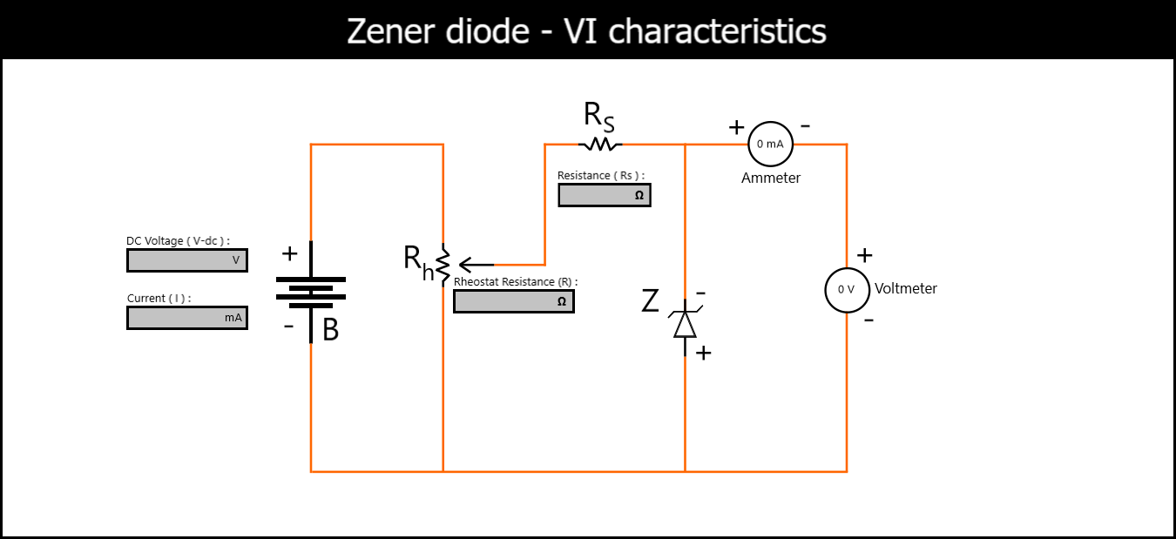

**LINE REGULATION IN A ZENER DIODE:**

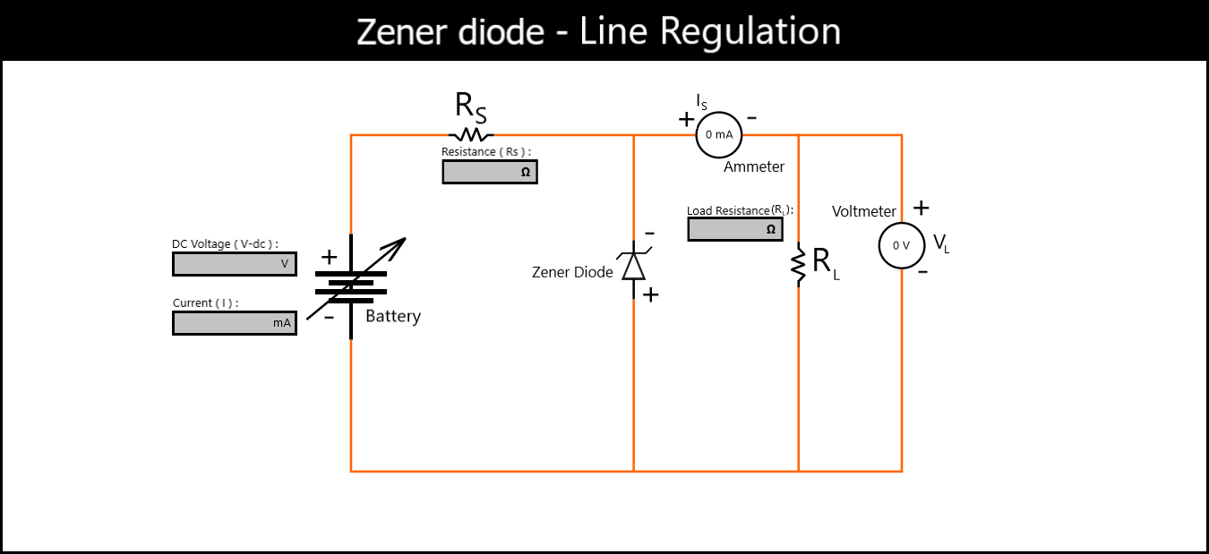

**LOAD REGULATION IN A ZENER DIODE:**

